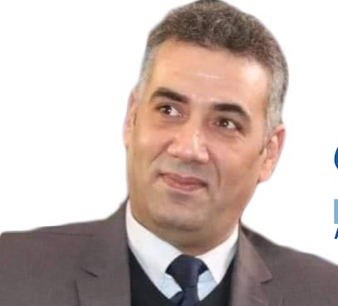

APS- New General Director

Profile of Mr. Samir GAID

Mr. Samir GAID is the new Director General at the Algerian Press Service agency, based in Algiers, after having spent more than two years as Director of the western region of APS in Oran from the beginning of 2019 to 2021, date of his appointment as Director General of APS.

Graduated in Political Sociology from the University of Oran, he was a journalist at the public newspaper En-Nasr since 2000, regional bureau chief of the same newspaper from 2002 to May 31, 2008 until he joined the APS Agency in June 2008. For the next 13 years, he focused on society and politics.

Contact details:

Telephone : +213 (0) 23569664
Mobile : +213 (0) 661 931 634
Email: gaidsamir.dgaps@gmail.com

